
2021 – Term 1
Year 8 Mathematics - End of Term Test

Resources: One A4 page of notes and a calculator

Name: _______________________________ / 51 marks Time: 50 minutes

Attempt all the questions.

Multiple Choice – Circle the correct answer 10 marks
- Which of the following is not an irrational number?
  - π
  - $\sqrt{2}$
  - $\sqrt{9}$
  - $\sqrt{3}$
- The perimeter of a rectangle is 30cm, if the length is 10cm what is the width?
  - 20cm
  - 10cm
  - 9cm
  - 5cm
- What is the area of the a square with a side length of 4m?
  - $4m^{2}$
  - $16m$
  - $16m^{2}$
  - $13m^{2}$
- $6×2÷4+2$ is equal to…
  - 2
  - 5
  - 15
  - 3
- A triangle has a height of 10cm and a base length of 7cm, what is the area?
  - $35m^{2}$
  - $70m$
  - $17m^{2}$
  - $70m^{2}$
- Which of the following fractions are terminating?
  - $\frac{1}{3}$
  - $\frac{5}{6}$
  - $\frac{1}{4}$
  - $\frac{1}{7}$
- Which percentage is equal to $\frac{3}{5}$?
  - 60%
  - 50%
  - 30%
  - 35%
- Which formula can be used to find the area of a parallelogram?
  - $\frac{1}{2}bh$
  - $lw$
  - $bh$
  - $\frac{a+b}{2}h$
- $4a+6a-3a$ simplifies to
  - 9a
  - 13a
  - 7a
  - 0
- To convert km to cm we can multiply by
  - 10
  - 1000
  - 100000
  - 1000000

Short answer- answer all the questions 40 marks
- [2 marks]
Travis and Adam are arguing over who has the correct answer to the following question
$$\left(3+4\right)×6-2$$

Travis says the answer is 28, while Adam says the answer is 40.
Who got the answer correct? (show your working out)

- [5 marks]
  - Tick the appropriate boxes
Number | Rational | Irrational
$$\sqrt{35}$$
$$\sqrt{64}$$
$$\frac{1}{3}$$
π

  - Which of the previous numbers are terminating decimals?

- [4 marks]

Complete the following table

Percentage | fraction | Decimal
50%
 | $$\frac{1}{4}$$
 |  | 0.2
 | $$\frac{1}{3}$$

- [2 marks]
A square has the area of $3cm^{2}$. Calculate the exact length of the sides of this square.

- [4 marks]
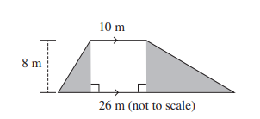
  - Find the area of the shaded area

  - Is it possible to find the area of the individual triangles? Explain why or why not.

- [13 marks]
Find the perimeter and area of the following shapes
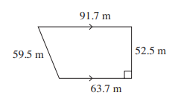 | 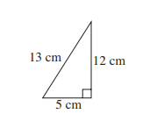
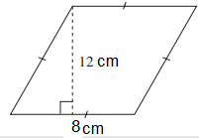 | 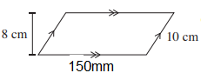

- [5 marks]
Martin wants to paint his kite a nice red colour. He knows that the kite was made with 2 poles that are 0.5m and 0.8m respectively.
    - What area will Martin need to paint?

    - If one tin of paint can cover 20,000$cm^{2}$, how many tins of red paint does Martin need?

- [3 marks]
3 people on a farm were given 5 minutes to pick as many apricots as they can. They get to keep all the ripe apricots they pick, as well as an equal split of 30 ripe apricots between the 3 of them that they picked earlier that day.
If Justin (one of the 3 people) picks 33 apricots, 15 of which are unripe, how many apricots does Justin get to keep in total?

- [2 marks]
Coralee takes out a loan of $2200. She pays back $42.60 each month without interest. If she has made 5 repayments so far, how much does Coralee still owe?

